|  |  |
| --- | --- |
| **Name :-** | Aryan Dilipbhai Langhanoja |
| **Enroll No: -** | 92200133030 |

## Electronic lock using basic logic gates

* **Aim** :-

To study the application of a combinational electronic lock using basic logic gates. The user will be able to design a 4 digit electronic code lock using two-input basic logic gates. Using the generalized simulator, the user can implement his design and verify its working.

* **Pre-test :-**

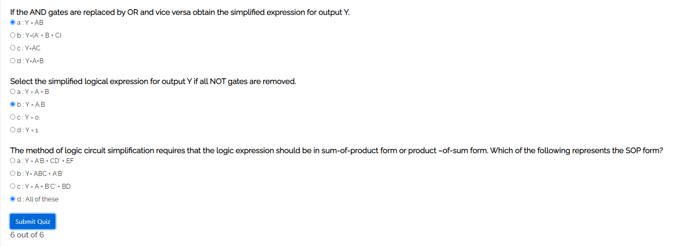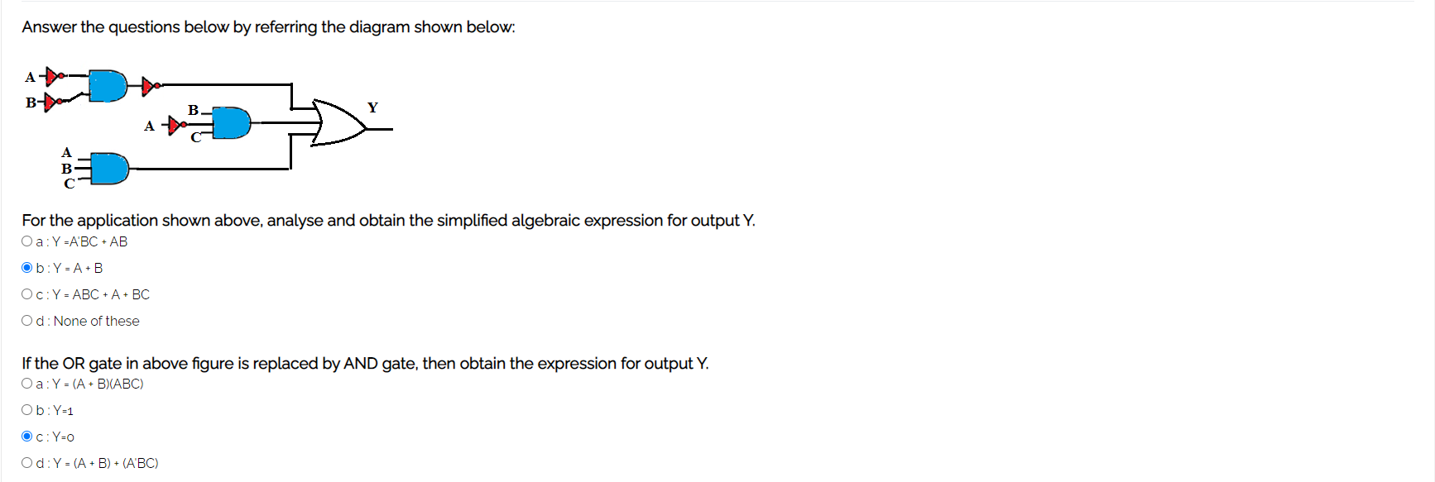

* **Simulation :-**

**Task:-** Design a three input electronic lock that operates when A = 1, B = 0, and C = 0. Construct and verify using simulator.

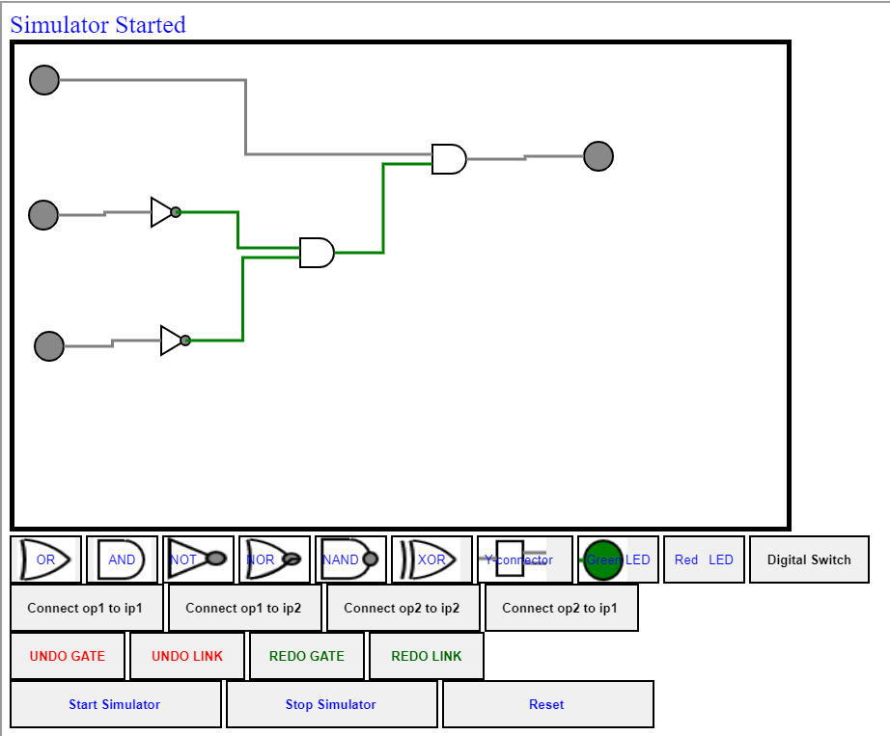

* **Post-test :-**

